Politics of public health
The Opioid Epidemic
Mike Conry

Introduction:
In the United States there is a growing public health crisis of people who become addicted and overuse prescription and illegal drugs, specifically opioids. Opioids are one of the most dangerous and most addictive prescribed drugs in the country. Everyday millions of peoples lives are effected negatively by these drugs, and in this paper I will explain the dangers, effects, facts and possible solutions surrounding this crisis.
Background:
Opioids are a specific kind of drug that binds the opioid receptors in the body and mind. They are a highly addictive substance that are typically prescribed to treat and relieve pain. These types of drugs come from the Opium plant, which became available in the US in 1775. In the 1860s, opioids became used to treat soldiers and because of this treatment many of them became addicted. Since then there has been many attempts to restrict opioid and narcotic use in the US such as the Harrison Narcotics Act of 1914 and the movement in the 70’s of doctors and medical professionals who chose to prescribe less opioids due to stigma. Today the opioid crisis has taken a turn for the worse.
Recently the Department of Health and Human Services (DHHS) tells us that in 2018 two million people had an opioid use disorder, 808,000 people used heroin, and 10.3 million people from ages 12 and up misused prescription opioids (hhs.gov). And even worse is the rate at which people die from these awful drugs. 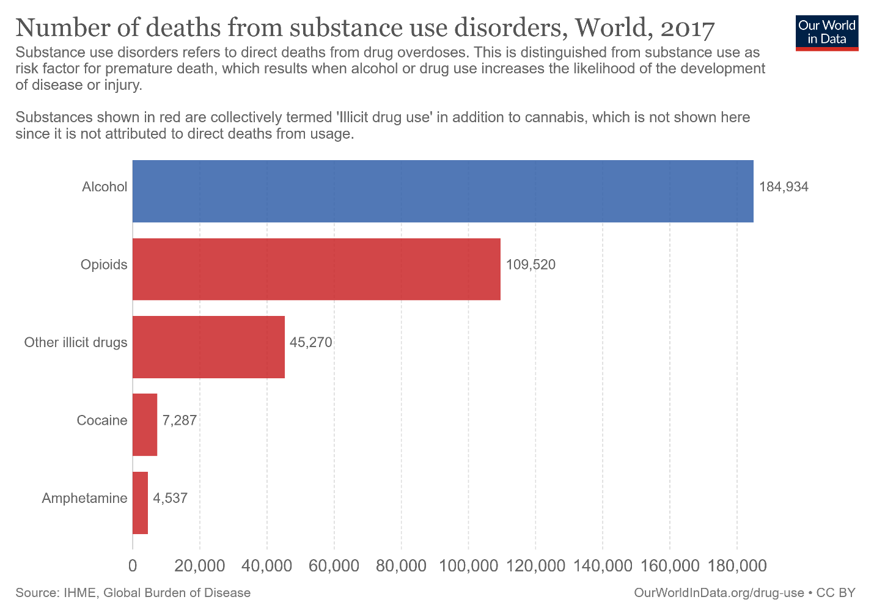
As you can see from the graph above, opioids are the second highest fatality addictive substance in the United States, second only to alcohol. Synthetic narcotics/opioids, prescription opioids and heroine are the top three most deadly drugs due to their ability to cause an overdose. In the US over 130 people die everyday due to overdoses caused by opioids. And typically, the likelihood of overdose does not deter addicts from using due to their addiction to the drugs.
The Center on Addiction defines addiction as, “…a complex disease, often chronic in nature, which affects the functioning of the brain and body.” It is the body and mind’s needing and craving of a substance, this craving causes loss of inhibitions, obsession with the addictive substance and an inability to stop using (medicalnewstoday.com). Addiction is one of the world’s most misunderstood disorders and costs the United States over $600 billion every year (addictioncenter.com). And with this misunderstanding comes stigma associated with this disease. A study by the Johns Hopkins Bloomberg School of Public Health found that people were statistically more likely to have negative feelings and stigma towards drug addicts and those coping with mental illness (drugabuse.com). This stigma becomes the reasoning and rationale for others to make harsher laws, further criminalizing the drugs and also the addicts. All this stigma and negativity towards addicts deter them from getting better and seeking treatment. Which thereby strengthens the reasonings of those who believe the stigma.

Options:
Since Presidents Trump’s inauguration in 2016, he and his administration have recognized and have taken action in order to correct this crisis. In 2017 the Trump administration declared the opioid crisis a public health emergency and in 2018 unveiled legislation called the Initiative to Stop Opioid Abuse (ISOA). ISOA is a policy directed to attack the opioid crisis in three parts. Part I is dedicated to reducing the demand and supply of prescription opioids in the public. This is done by educating the public on the dangers of opioids and addiction and decreasing the over-prescription of opioids to treat chronic and non-chronic pain. Part II is designed to cut down the supply of illicit and illegal drugs that devastate low income communities. This is done by cracking down on domestic and non-domestic drug supply chains. Part III is possibly the most influential change this initiative has put forward. It is designed to help those who are addicted seek and go through treatment programs and recovery to treat their addiction.

Public Health:
Drug use in the United States is one of the foremost important public health issues. It affects millions of Americans every day and leads to dangerous elevations of crime and drug abuse in low income communities. One of the greatest causal factors of this issue is the over prescribing of opioid drugs as medical treatment. Since such actions overall have come up to clean up the opioid abuse problem in the United States, policy advisors and public servants have begun hammering down legislation and campaigns against the prescription drug industry to disincentivize doctors in prescribing opioid drugs. Since this approach has been a widely favorable option in public opinion, the rate of prescribing opioids to patience has begun to see a turn to our delight.
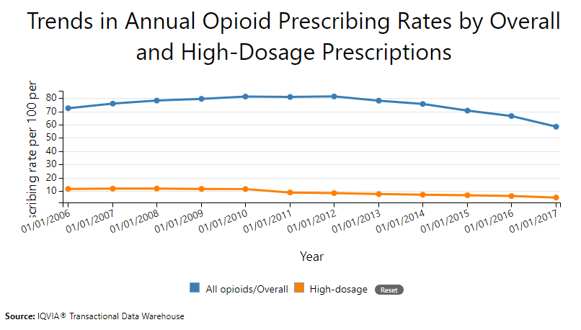
This graph shows that since the peak in opioid prescription rates in 2012, the overall rate of prescribing not only opioid drugs has gone down, but also the size of the dosage. Thereby making it safer for those who do need these drugs and also ensuring those who do not can receive alternative drugs. And to this day more and more doctors are being incentivized to prescribe even less and less in order to combat with the risk of rising addiction rates.

Political Factor:
Politics are probably the most influential factor in determining what action takes place in government. In American politics there are generally three parties whose beliefs dominate the political field, which includes thoughts on subjects like taxes, foreign policy, education, immigration and our topic of opioids. These political parties who dominate the field are Democrat, Republican and Independent. In most arguments it is easily seen that Republicans and Democrats disagree on almost every subject. But in a recent article by drugabuse.com, it was found that the majority of members from each party believe that not only should drug laws be less strict, but also that the United States should emphasize programs of rehabilitation over incarceration (drugabuse.com). This inquiry not only studied those from each political party, but

also demographics of age and gender, and even though there were some varying percentages the majority of all people across all demographics believe that the United States should adopt less strict laws for those who are addicted to drugs especially opioids.
This statistic is particularly surprising due to some fundamental political and ideological differences between democrats and republicans. Democrats typically believe in a less criminalized state in the hopes of downsizing the amount of incarcerated citizens per capita the United States has. This includes reforming laws such as drug laws to be more reformative than punitive. Republicans however typically take a more harsh approach. One of the main arguments and beliefs in the republican party is one of being “tough on crime.” This includes and is rather specifically targeted towards drug use and non-violent crimes in the hope of deterring criminals from their chosen “profession” of crime. But it turns out that today it seems that the parties can agree in this regard.

Economic Factor:
The War on Drugs has been as much an economic undertaking as much, if not more, than it has a been one of public health. Since 1971 when President Richard Nixon first announced the United States commitment to the war on drugs, the amount of money being spent to counteract the illegal drug trade and abuse has risen substantially. The war on drugs has estimated to have cast the United States, so far, over $1 trillion (americanprogress.org). Not only does the United States spend approximately $51 billion every year out of the federal budget in programs to counteract and aid in the war on drugs, but also spend an estimates $9.2 million everyday to incarcerate people whom have been charged with drug related offenses.
The war on drugs calls on us and the policy makers to not only stop this corruption of our values through policing and public health needs, but also to stop it through economic standards. These standards are to not only preserve our ability to govern responsibly and fiscally withing the confines of the budget. But also, to use economic means as a form of warfare against those in central American states whom are the suppliers of the drug trade. It is estimated by the US Department of Homeland Security that the cartels in Mexico and central American countries take in between $19 billion and $29 billion in revenue from their drug trade enterprise in the United States. This money not only funds their gangs across Mexico, Brazil, Bolivia, and many other Latin American countries. But also, funds gangs and other cartel organizations in Canada and the United States. And the United States is taking tremendous strides in taking economic action against the cartels beginning at the border.
The US border with Mexico is one of, if not the most active hub of drug relative travel and trading from the cartel to its fellow gang members in the states. The border control, both by Mexico and the United States, searches and seizes millions of dollars in lost revenue and assets sent to the states by the cartels. These assets come in the form of drugs, guns, ammunition, and money being sent to and from the cartel in the states and Mexico. This is just as much an economic war as it is a public health and police war.

Social Determinants:
Social determinants are significantly tied to factors surrounding the opioid epidemic. This is due partially due to the availability of hard narcotics in low income communities. Both high and low socio-economic status communities experience different forms of crimes, this includes drug use. This is not only a public health issue for those in low socio-economic status communities, but also to those in the middle- and upper-class communities. Throughout each class comes with it people who have a dependency on opioids and other narcotics, and disproportionate resources to allocate these drugs. Addictioncenter.com writes a thorough and informative article on the price of various drugs illegally used and abused in the United States. We can not only estimate but find evidence of how the price of these drugs affects what comes available and typically used in each socio-economic class.
Starting at the lowest income communities we find that well known drugs such as heroin, Percocet, Tramadol and many other cheap drugs are easily accessible for those who are in the lowest economic classes. The middle class has much more fluidity with regards to accessing illegal drugs today. Drugs such as Oxycodone, OxyContin and other name brand drugs, whilst also being able to access the drugs well known in the lowest economic communities as well. And the upper class Americans can not only easily access the drugs in the communities economically below them, but also much more expensive narcotics such as Fentanyl which costs at least $40 per pill. Ones access to illegal drugs, not only including prescription drugs, is determined by ones socio-economic status. The drugs in lower income communities are not only more feasible to buy, but also are far deadlier.

Legal Factor:
Some legal issues regarding the war on drugs and more specifically the opioid crisis result from the legislative and executive branch’s harsher criminal laws surrounding the topic. These laws which are under dispute are laws that the ACLU (American Civil Liberties Union) fight vehemently against. It is their opinion that these drug control laws are unconstitutional because, “…it subjects otherwise law-abiding citizens to arrest, prosecution, and imprisonment for what they do in private.” It is the opinion of the ACLU and other organizations like it that Americans should be free to do as they want in the privacy of their own homes and businesses as long as their practices do not harm others. Even if this includes harming themselves. This misguided opinion stems from the Constitutions Fourth Amendment where its enumeration on a persons right against unreasonable search and seizures gave precedence to another constitutional right to privacy. Although this is not an enumerated right in the constitution, much support of this precedence has erupted recently due to the new digital age we find ourselves in.
Recommendations:
There have been many recommendations towards our betterment in the war on drugs throughout its time since 1971. These include discussions on increasing or decreasing border control security, increasing funding towards counter-intelligence agencies like the FBI and CIA, increasing military oversight in Mexico and many other platforms of change. It seems like the easily solution would be to increase border security and to place more checkpoints throughout the region but this would not affect the issue much. Since 1990 the security at the border between the US and Mexico and tripled in not only funding but also on the ground personnel. And although they do tremendous work in their own way with their searches and seizures of people legally crossing the border we still have the issue of people and drug traffickers illegally coming to the states. So an alternative approach should be considered in hopes to deter the cartel, or more aggressively stop them entirely.
My recommendation would be to help Mexico diversify its economy and bring in new jobs. By bringing in new jobs and help strengthening to Mexican economy, we deter Mexican citizens from pursuing any form of employment that pays. Citizens in Mexico are consistently at the mercy of the cartels because they will pay better than any job Mexicans can find. The average Mexican household makes $843 a month (13,239 pesos). This is hardly enough money to not only live on but to also support a family on. If the United States were to not only lift up its tariffs and sanctions on Mexico, but also forgive the debt Mexico owes to the US and provide military support to counteract gang prevalent regions. Then Mexico could begin to further thrive economically and have an outward and southern expansion of cities and jobs. This would strongly encourage the citizens of Mexico to not only stay out of the business of cartels but also would restore the faith of the Mexican citizens in their government thereby cutting the rate of Mexican citizens illegally entering the United States for work.

WORK CITED:
“11 Unbelievable Facts about Mexico's Economy | Markets Insider.” Business Insider, Business Insider, markets.businessinsider.com/news/stocks/mexico-economy-facts-disproportionate-poverty-2019-6-1028281403#mexico-s-drug-cartels-earn-as-much-as-49-4-billion-a-year7.
“Against Drug Prohibition.” American Civil Liberties Union, www.aclu.org/other/against-drug-prohibition.
“Mexican Households Have an Average of 3.8 Members, $843 in Monthly Income.” Www.efe.com, 16 July 2015, www.efe.com/efe/english/life/mexican-households-have-an-average-of-3-8-members-843-in-monthly-income/50000263-2666718#:~:text=The average household income is,($9,147) every three months.

